

SIMATS ENGINEERING

Saveetha Institute of Medical and Technical Sciences Chennai- 602105

Student Name: R.Mahesh Reg.No.:192312496Course Code: CSA0211 Slot: B
Course Name: C-PROGRAMMING
Course Faculty: Dr. K. S. SARAVANAN

Project Title: Smart University Laboratory Equipment Monitoring and Allocation System using C
Module Photographs:
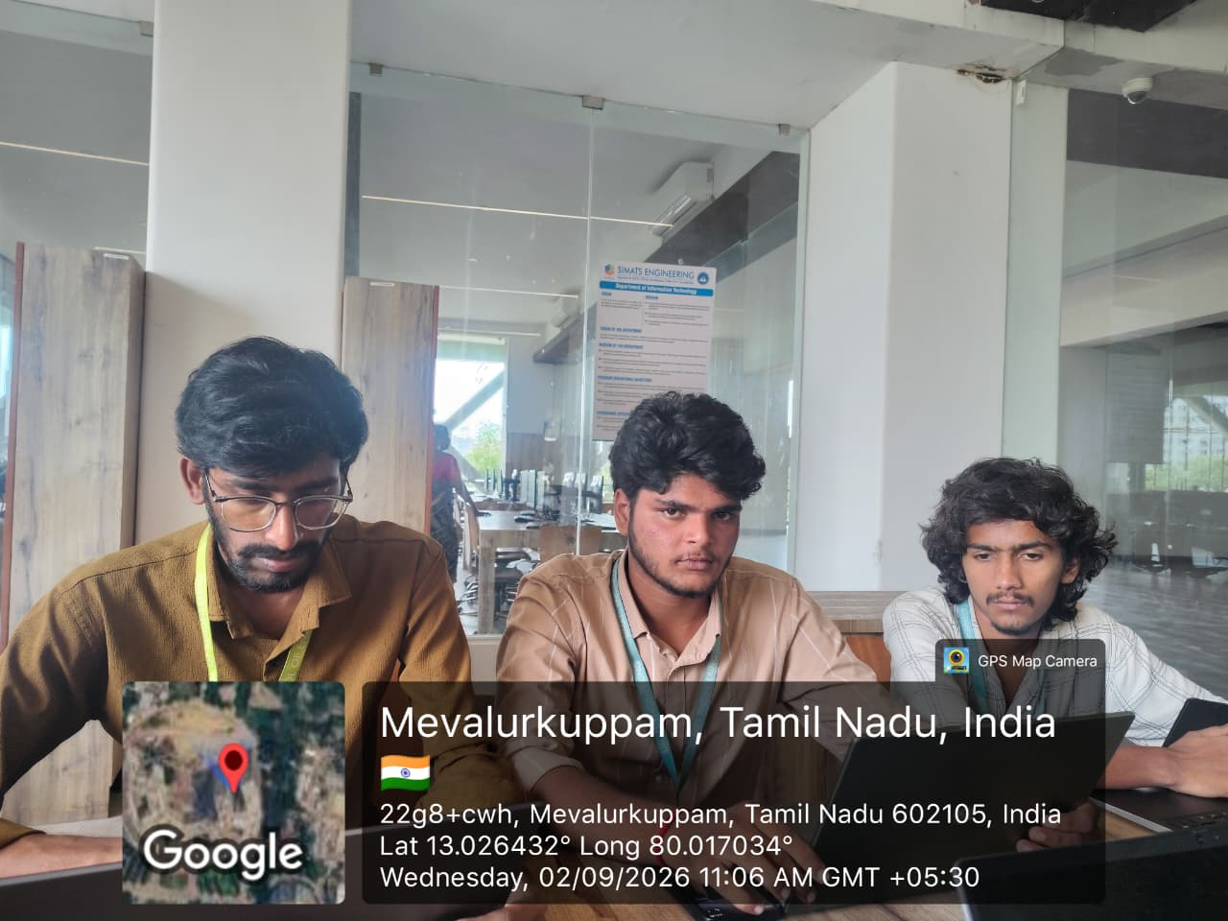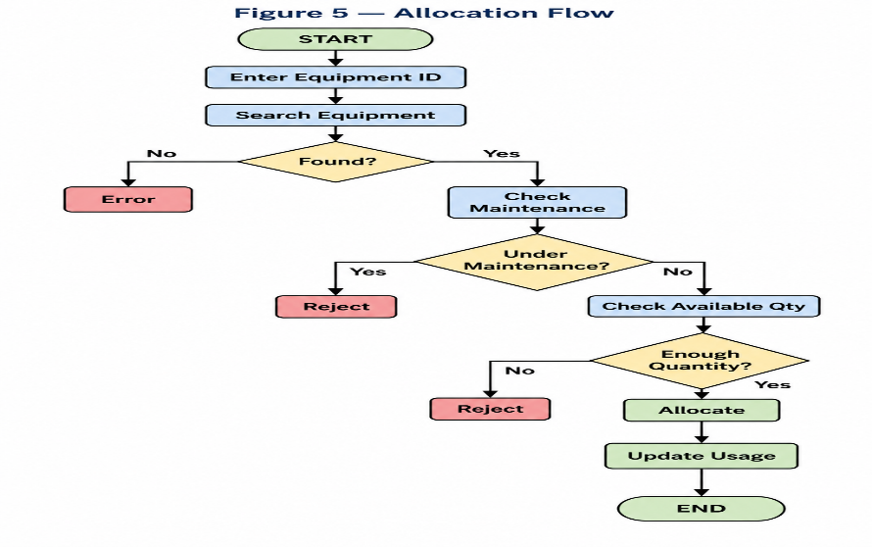
Project Description: (here you write what you did in this project (contribution) including Model Description
The project titled “Smart University Laboratory Equipment Monitoring and Allocation System using C” was developed to manage and monitor laboratory equipment efficiently. The system allows users to add, update, display, search, sort, and allocate laboratory equipment. It also monitors equipment availability, condition, usage count, and maintenance status. The project uses C programming concepts such as structures, arrays, functions, pointers, searching, sorting, recursion, and file handling. The model helps identify low-availability and critical equipment, supports equipment allocation, and generates consolidated reports. My contribution included developing the core program logic, implementing equipment management and allocation features, searching and sorting operations, status analysis, and file-based data storage.

Student Signature Guide Signature

